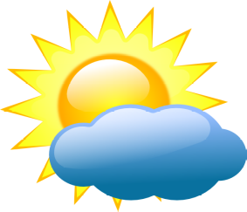


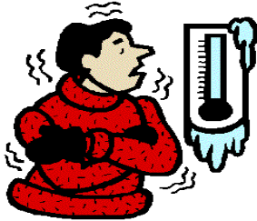
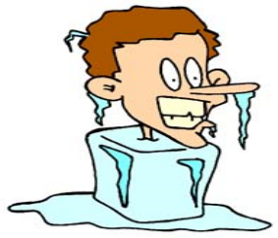

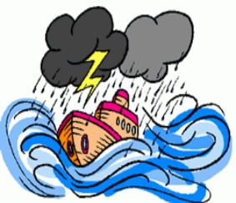
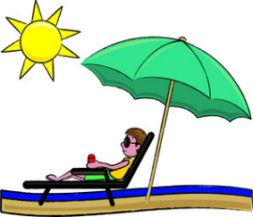




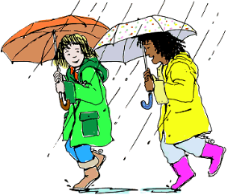
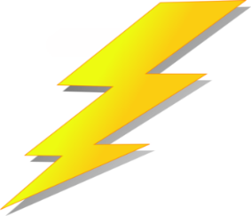

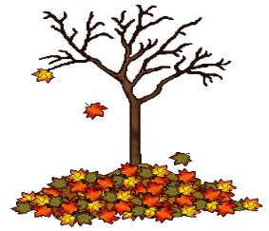
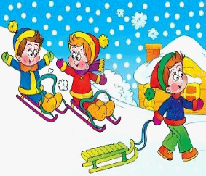


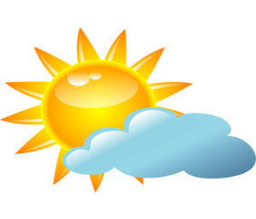


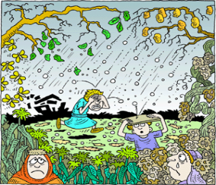
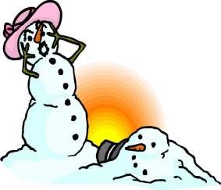

Sunny
Cloudy
c) Partly cloudy

Thunder
Clear sky
Cloudy
Warm
Hot
Cold
Wet
b) Below zero
c) Cold
Sweating
Freezing
Snowing
Dry
Wet
Frosty
Foggy
Overcast
Gloomy

Arch
Rainbow
Sunrays

Dry
Lovely
Raining
Stormy
Thawing
Calm

Lightning
Thunder
Thunderstorm
Breeze
Windy
Hurricane

Fall
Autumn
Winter
Nice
Warm
Sunny
Snowstorm
Winter
Autumn
Snowy
Rainy
Frosty

Drought
Flood
Dry
Drought
Dry
Hail

Smoggy
Misty
Clear
Hot
Boiling
Warm

Beautiful
b) Clearing up
c) Pleasant

Summer
Autumn
Spring
pring
Sleet
Hail
Storm

Freezing
Thawing
Snowing
Sunshine
Summer
Sunlight

Choose the correct answer.

